
2026 A Safety Awareness Program (ASAP)
NEW HARTFORD LITTLE LEAGUE
P.O. BOX 202
New Hartford New York 13413
Newhartfordlittleleague@gmail.com
http://www.newhartfordlittleleague.com
LEAGUE ID: 232-10-14

Created: April 19, 2026

The purpose of the New Hartford Little League (NHLL) Safety Plan is to develop guidelines for increasing the safety of activities, equipment, instruction and facilities through education, compliance, and reporting. In support of this goal, NHLL also commits itself to providing the necessary organizational structure and focus to develop, monitor, and enforce compliance with all aspects of the plan.

The Safety Plan includes the Code of Conduct and Safety Code adopted by the NHLL Board of Directors. These documents outline specific safety-related policies and procedures of the League. All participants, volunteers, employees, spectators, and guests are bound by the guidelines set forth in these documents. The plan is distributed to all Board Members, all Managers, Coaches, and Team Parents. It is also published on the league website, and a copy is kept in the NHLL Board Room. A copy will be submitted by Safety Officer or League President to District 10 district safety officer, and a copy will be submitted to Little League International

As a coach, volunteer, or parent, the single most important part of participating in youth sports is the safety of the children.

It is the responsibility of all of us to keep an eye out for any safety concerns and take the necessary steps to help prevent any unsafe practice.

- LEAGUE SAFETY OFFICER

James Graeff, 2026 New Hartford Little League Safety Officer

Safety Officer Contact:
James Graeff 315-404-1503 JimmyG802@gmail.com

The League Safety Officer is an elected Member of the New Hartford Board of Directors. This individual acts as the New Hartford Little League primary point of contact for the safety issues and is responsible to review, modify and communicate the League’s Safety plan each year. The plan is presented to our district safety officer for review and to Little League International each year for approval. Upon approval by Little League International, it becomes the responsibly of the New Hartford Little League Board, Coaches, Players, Parents and Spectators to administer and assure adherence to its contents. The New Hartford Safety Officer is registered and on file with Little League International.

- DISTRIBUTION OF SAFETY PLAN

A copy of the 2026 safety plan will be distributed to all managers, coaches, volunteers, and the district safety officer. We will distribute the plan electronically through e-mail, but will make paper copies available upon request, as well as at the NHLL Field. We will provide a link to the safety plan on the New Hartford Little League website at:

http://newhartfordlittleleague.com

- EMERGENCY AND LEAGUE OFFICER CONTACTS

IN THE EVENT OF AN EMERGENCY, DIAL 911

Police and Fire Department numbers are posted in the concession stands for non-critical situations. Board member telephone numbers are published in this safety plan.

New Hartford Police Department 315-733-6666
New Hartford Fire Department 315-732-1710
Upstate NY Poison Control 1-800-222-1222
National Grid emergency 1-800-892-2345

President: Salvatore Paladino 315-240-7580
Vice President Lisa Calli 845-235-5529
Treasurer Peter Logue 703-220-8365
Safety Officer: James Graeff 315-404-1503

LL Commissioner: Benjamin Perra 315-794-9286
Minors A Commissioner: Tara Anguish 315-542-5717
Minors B Commissioner: Jeremy Godfrey 315-525-7222
T-Ball Commissioner: Derek Wilcox 315-292-3925

Facilities Manager: Matthew Sprague 315-794-6160
Equipment Manager: Sean Virkler 315-272-6659
Concessions coordinator Noelle Sprague

https://www.newhartfordlittleleague.com/Default.aspx?tabid=1866057

Always have a cell phone with you or with someone on your team during all games and practices.

- VOLUNTEER APPLICATIONS

New Hartford Little League will use the official 2026 Little League Volunteer application form to screen all (new/returning) volunteers. NHLL will use J.D. Palatine (JDP) to conduct background checks.

- FUNDAMENTALS TRAINING

Suggested books are: Little League Drills & Strategies; Managing Little League Baseball; Coaching the Little League Pitcher; & Big Al Coaching books. T-Ball Managers will get a copy of The Little League T-Ball program manual upon request. Links to the Little League training resources in the Little League University are provided. Managers and Coaches in all New Hartford Little League divisions are required to instruct children in the above-mentioned fundamentals as appropriate for each division.

Additional training extents to good safety habits, including: 1) transportation to/from the ballpark, 2) designated warm-up areas, 3) spectator areas, 4) foul ball procedures, 5) heat illnesses and warning signs etc. Managers and coaches in all league divisions are required to discuss safe transportation to and from games and practices with the parents and players. No fewer then two adult coaches will be present at all events. Managers and coaches are instructed to communicate to all players, monitor, and enforce all little league rules and proper equipment use for each position, including equipment for players who warm up pitchers.

- FIRST AID TRAINING

The league will require that at least one coach from each team obtain first-aid training.

Links to become certified can be found at the following websites:

https://www.littleleague.org/university/articles/first-aid-awareness-training-course/

https://www.redcross.org/take-a-class?gclsrc=aw.ds&gad_source=1&gad_campaignid=17005484042&gclid=Cj0KCQjw-pHPBhCdARIsAHXYWP9EdmPZuvvl7_JHjbnHFZVG1S6W9H5FoMi-bZHgDatsgIQg7QN7sHMaAgFrEALw_wcB

- FIELD INSPECTIONS

Managers, Coaches and umpires are required to walk and inspect the playing fields before any use to check for holes, damage, glass, and other hazards. Any immediate hazards should be corrected and/or reported to league officials.

- ANNUAL LITTLE LEAGUE FIELD SURVEY

The 2026 facility survey has been submitted to the Little League Data Center.

https://www.newhartfordlittleleague.com/Default.aspx?tabid=1866058

For player safety, all NHLL bases disengage, and safety netting is used for foul ball protection.

New Hartford Little League will utilize the following field locations:

Tee-Ball Field – Rec Center
4 Mill Street New Hartford NY 13413
Field #1

Minor B Field – Myles Elementary
100 Clinton Rd New Hartford, NY
Field #1

Minor B Practice Field – Sherrill Brook Park
Sherril Brook Town Park New Hartford, NY 13413
Field #1

Minor A Field – Washington Mills Athletic Park
3695 Oneida St Washington Mills NY 13479
Field #1

Minor B Practice Field – Sherrill Brook Park
Sherril Brook Town Park New Hartford, NY 13413
Field #2

Minor A Practice Field - Donovan Memorial Park - Chadwicks
9400 Elm St Chadwicks, NY
Field #1

NHLL Field – Ambrose D. Eldred Memorial Field
8 Bonnie Lane New Hartford, NY 13413
Bonnie Lane

Fall Ball Field – Addison Mill Park (AMP)
O’Brien Ave Utica, NY 13502

Accelerate
5241 Judd Road Whitesboro NY 13492
Outdoor Field

- CONCESSION STAND SAFETY

Concession stand safety procedures will be displayed inside the concession stand. The following guidelines will apply.

It is the staff’s responsibility to ensure all notices pertinent to food hazards, i.e. choking, hand washing, etc. are clearly visible. It is also their responsibility to advise the Board of Directors of any safety or other equipment necessary to operate a safe and healthy food establishment.
The concession stand must be kept clean and neat at all times. Wet, slippery floors will undoubtedly cause accidents.
All staff must be properly trained in the use of all equipment and advised to report any defective equipment immediately. Domestic hot water must be kept at a temperature to guarantee proper sanitation of utensils and regulated to hand washing areas to avoid a scalding hazard.
Refrigerators must be maintained to a temperature of 40 degrees; all freezers must maintain a temperature of -10 degrees or below.
All soda equipment is to be inspected, cleaned, and secured for safety.
Pest control prevention is scheduled on a regular basis.
Regular inspections of the concession stand are mandated by the league and certified by the Oneida County Board of Health.
Any and all spray bottles SHALL be clearly marked with the contents.
All trash will be disposed immediately to the designated areas for pick-up after every game.

- EQUIPMENT INSPECTION

The league equipment manager, Sean Virkler, and President of New Hartford Little League, Salvatore Paladino, inspected all equipment on March 21, 2026 prior to the 2026 season.

Defective equipment will be taken out of use immediately.

Coaches will inspect equipment prior to practices and games. Any equipment that is unsafe will not be used during practices or games. If any equipment is found defective the equipment manager will be notified as soon as practical.

Players are encouraged to have and inspect their own equipment, in particular bat and helmet, as well as catching gear for catchers.

- ACCIDENT REPORTING

All player injuries occurring during practices or games must be reported to the Safety Officer within 48 hours.

Accident reporting forms can be found on the Little League International website, or may obtained from the Safety Officer upon request. A link is here https://www.littleleague.org/downloads/accident-claim-form/

What to Report – an incident that causes any player, manager, coach, umpire, or volunteer to receive medical treatment and/or first aid must be reported to the Safety Officer. This includes even passive treatments such as the evaluation and diagnosis of the extent of the injury or periods of rest.
Who and When to Report – all incidents described above must be reported to the Safety Officer within 48 hours.
How to make the Report – reporting can come in many forms, typically they are by phone conversation. At a minimum, the following information must be provided:
- Name and phone number of the individual involved
- Date, time, and location of the incident
- Description of the incident (as detailed as possible)
- Preliminary estimation of the extent of any injuries
- Name and phone number of the individual reporting the incident.
Safety Officer Responsibilities
Within 48 hours of receiving the incident report, the Safety Officer will contact the injured party or the party’s parents and (1) verify the information received; (2) obtain any other information deemed necessary; (3) check on the status of the injured party; and (4) in the event that the injured party required other medical treatment (i.e. emergency room visit, doctor visit, etc.) will advise the parent or guardian of the New Hartford Little League’s insurance coverages and the provisions for submitting any claims.
If the extent of the injury is more than minor in nature, the Safety Officer shall periodically call the injured party to (1) check on the status of any injuries, and (2) to check if any other assistance is necessary in areas such as submission of insurance forms, etc. until such time as the incident is considered “closed” (i.e. no further claims are expected and/or the individual is participating in the league again).
- FIRST AID KITS

All teams will be issued a First Aid kit and are required to have them at all practices and games.

Additional kits will be stored at field locations, to the extent possible. At the Little League field, the storage location will be the press box and/or concession stand. At the Minors field, the storage location will be the equipment shed.

Coaches and Managers prior to each practice or game will ensure their first aid kit is stocked and contains all supplies.

- ENFORCEMENT OF LITTLE LEAGUE RULES

All rules apply to practices, training, games, and any other Little League event.

Our league will enforce all Little League rules, including:
- Proper equipment for catchers - catcher’s helmet, mask, throat guard, chest protector, shin guards, and protective cup with athletic supporter. Players not wearing a protective cup are not permitted to play catcher at any level - NO EXCEPTIONS.
- No on-deck batters.
- Safety bases that disengage will be installed on all fields.
- Only players, coaches, and umpires are permitted on the field or in the dugout during practices and games.
- Batters must wear Little League approved protective helmets during batting practice and games.
- Players must not wear necklaces, watches, rings, pins, or metallic items during practices and games.

NHLL Code of Conduct

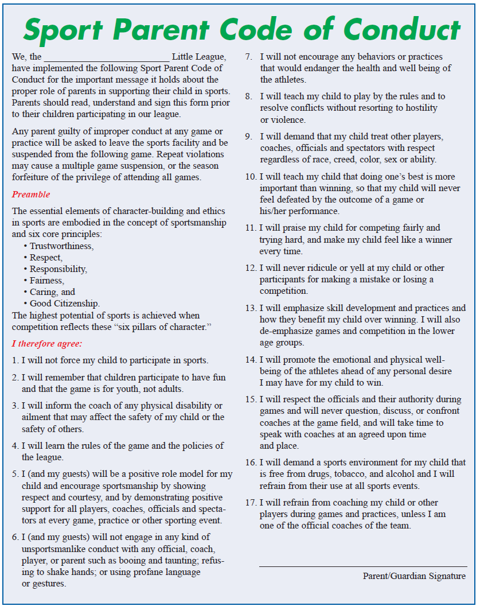

- PLAYER, MANAGER, AND COACH DATA

Player, manager, and coach information will be submitted through the Little League Data Center.

- SURVEY QUESTION

The league will answer the required survey question in the Little League Data Center.

- MISCELLANEOUS

Weather Safety

Weather protocols must be strictly followed.

A Board Member or Appointed Representative (“Board Member on Duty”) must be present at the facility when any New Hartford Little League-sponsored activity is underway.

The Board Member on duty is responsible for monitoring weather and keeping an Executive Board Member (typically the President) up to date on any weather-related concerns.

The Weather Channel app, RadarOmega app or similar app is recommended for monitoring forecasts and radar for weather related concerns.

The primary immediate weather threat is lightening. In the event of visible lighting strikes within a 6-10 mile radius, all activity will be suspended, and the park immediately evacuated. Communication with parents and participants will be accomplished through verbal communication, league text or e-mail, and social media. Everyone must move inside their vehicles until given the “All Clear” by the Board Member on duty or through Executive Board Member via verbal notification, league text or e-mail, and social media.

The following criteria should be used to determine when to halt activity:
- If lightning is observed
- If thunder is heard
- If the time between lightning and thunder is 30 seconds or less

Activities should not resume sooner than 30 minutes after the storm has passed, or the last instance of lightning is observed/thunder is heard.

Automatic External Defibrillators

In accordance with New York State Legislation, New Hartford Little League will have an AED available for every practice and game. Each level will be allotted one AED and coaches will obtain AED prior to practice or game for the League Commissioner. This policy will go into effect on April 1, 2026.

Each field location has at least one AED on hand.

APPENDICESAPPENDICES

Little League Volunteer form | https://cdn4.sportngin.com/attachments/document/381d-2663709/2025_Volunteer_Application.pdf

Accident Claim Form

Accident Claim Form Instructions

Little League Baseball Injury Tracking Report (league use only)
Little League Facilities Survey | Submitted online in the Data Center

Communicable Disease Procedures

Player Medical Release Form
H. NHLL Concession Operating Guidelines | Submitted with safety plan.

